# **NAME:- PONALA PRASAD**

**EMAIL** [**ID:- 2020ece.r74@svck.edu.in**](mailto:ID:-%202020ece.r74@svck.edu.in%20)

**Phone:- 8688264737**

# **ROLL NUMBER:- 20KH1A0474 (ECE)**

**COLLEGE:- SRI VENKATESWARA COLLEGE OF ENGINEERING ,KADAPA**

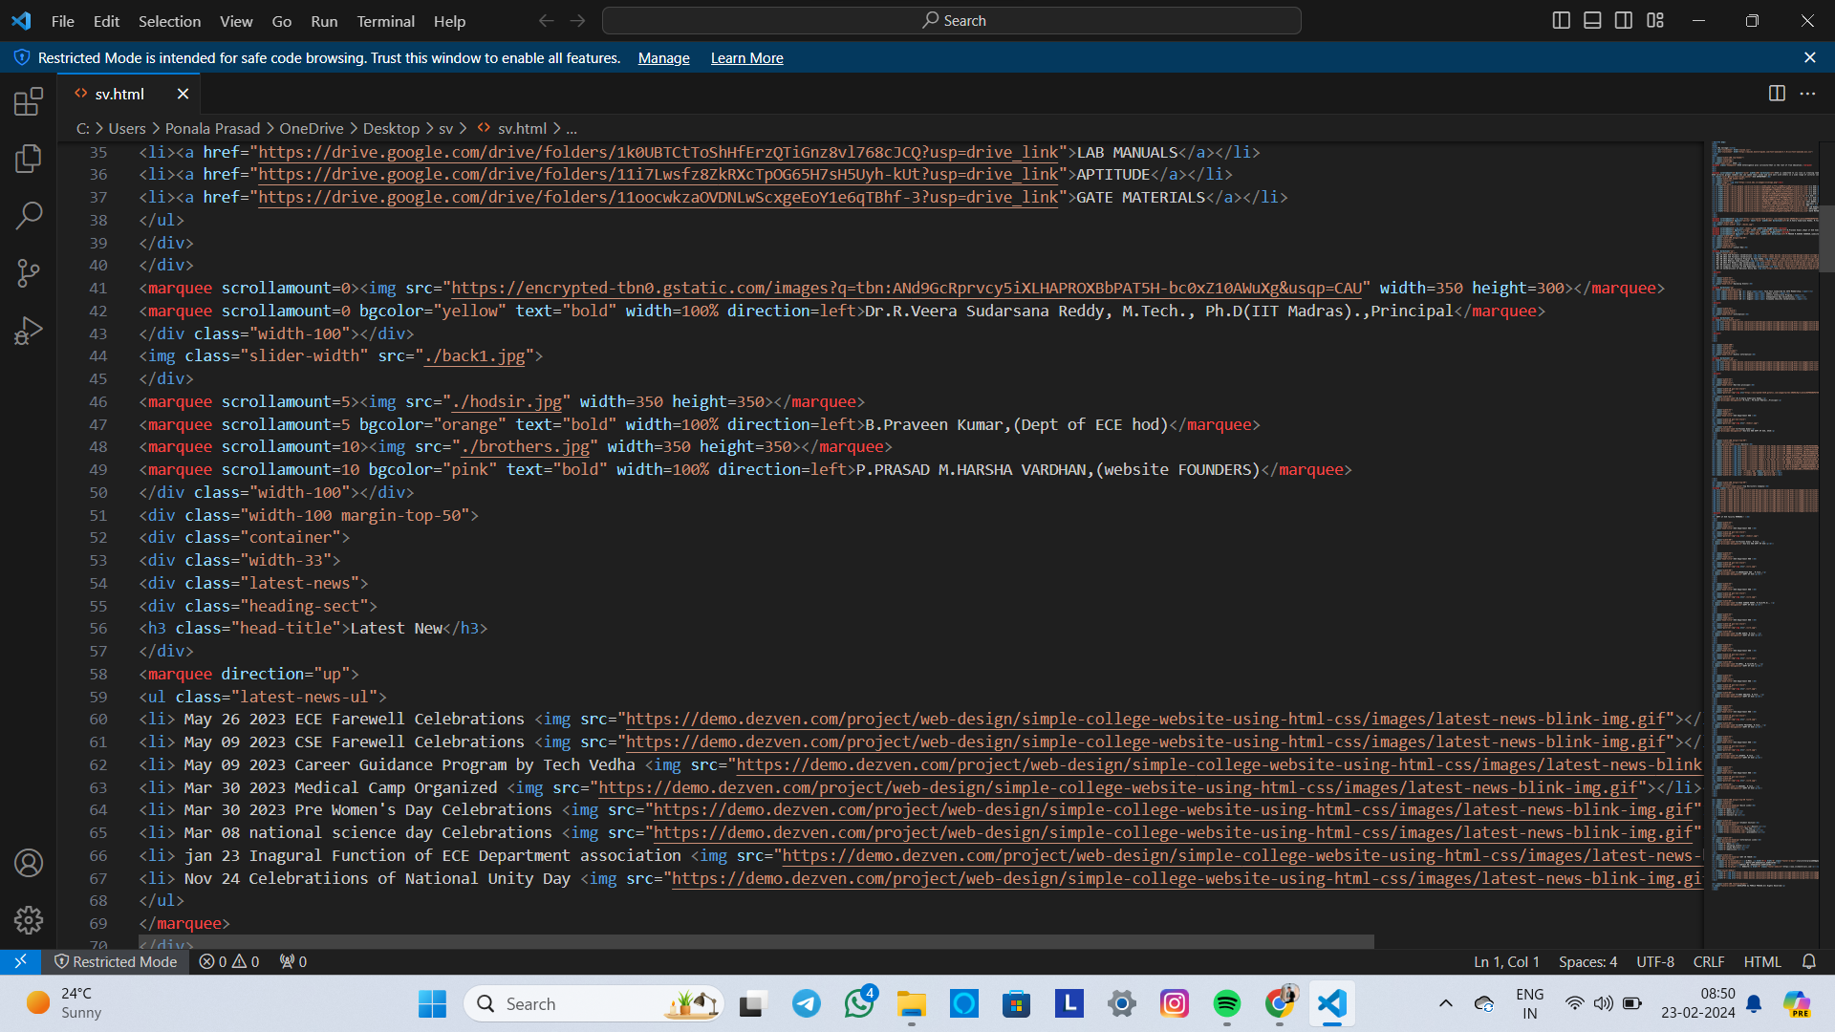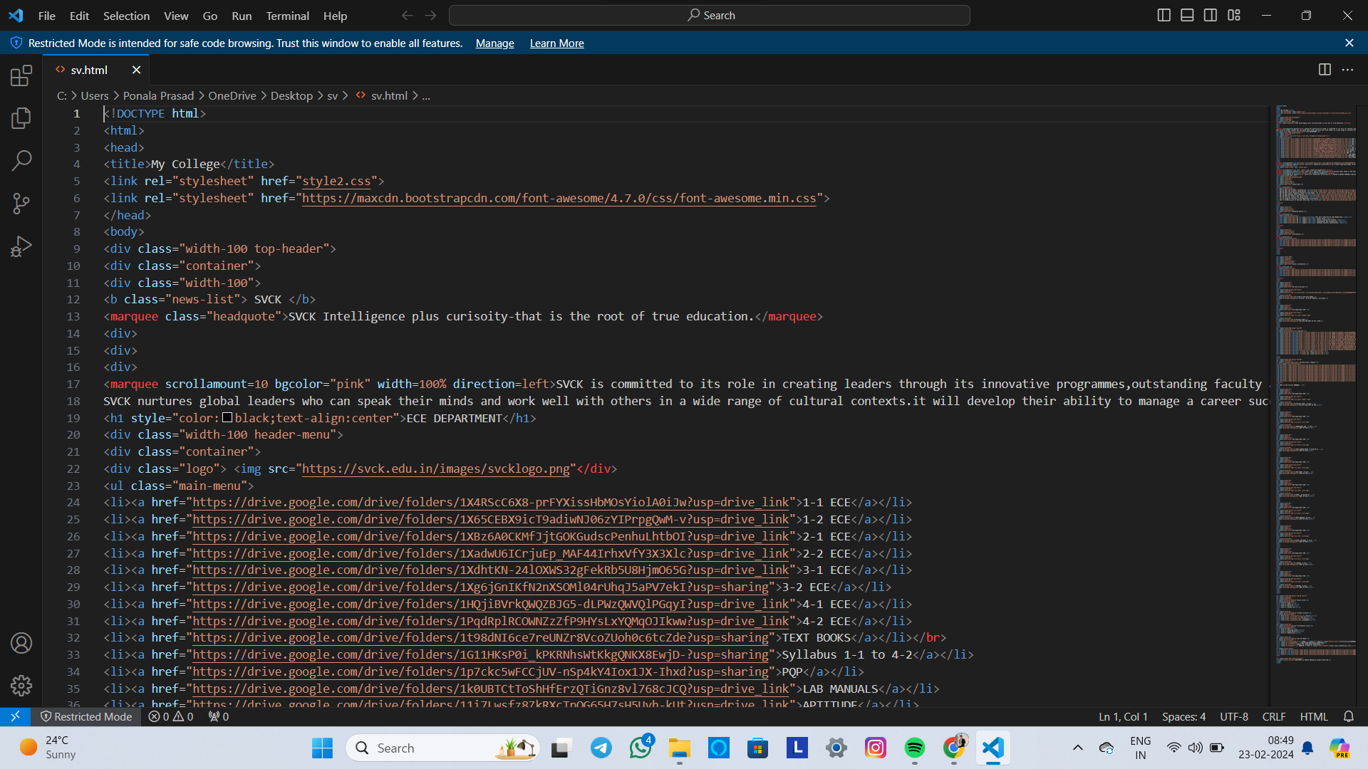

<!DOCTYPE html>

<html lang="en">

<head>

<meta charset="UTF-8">

<meta name="viewport" content="width=device-width, initial-scale=1.0">

<title>landing pages</title><style>

section{

min-height: 100vh; background-image:linear-

gradient(rgba(0,0,0,0.60),rgba(0,0,0,0.60)), url("https://images.unsplash.com/photo-1591378603223- e15b45a81640?q=80&w=1000&auto=format&fit=crop&ixlib=rb- 4.0.3&ixid=M3wxMjA3fDB8MHxzZWFyY2h8Mnx8a3RtJTIwZHVrZXxlbnwwfHwwfHx8MA%3D%3D");

background-repeat: no-repeat; background-size: cover;

}

.container{

width: 85%; margin: auto;

}

nav{

height: 80px;

}

nav h1{

float: left;

line-height: 80px; font-size: 35px; font-size: inline; color:#eb7620;

}

nav ul{

float:right;

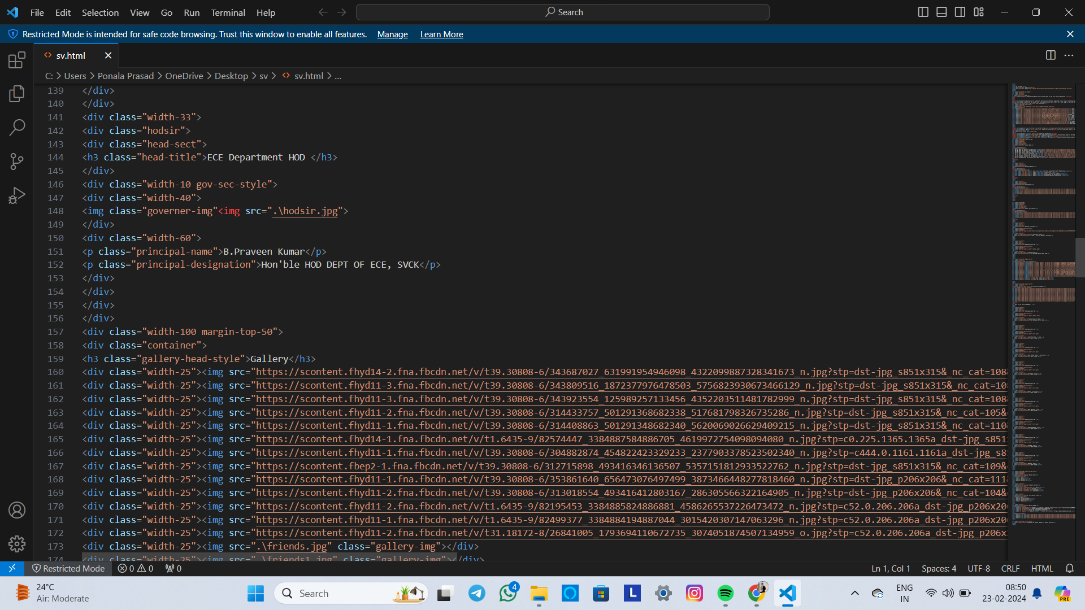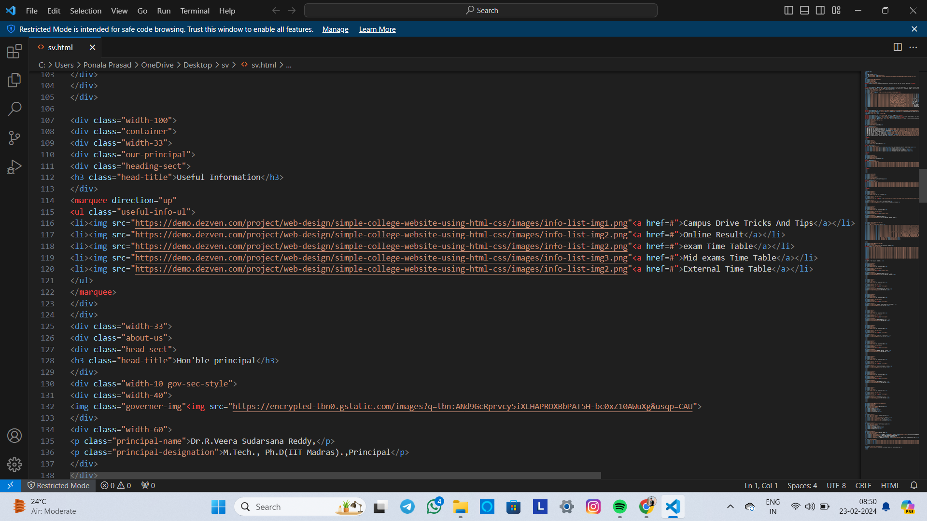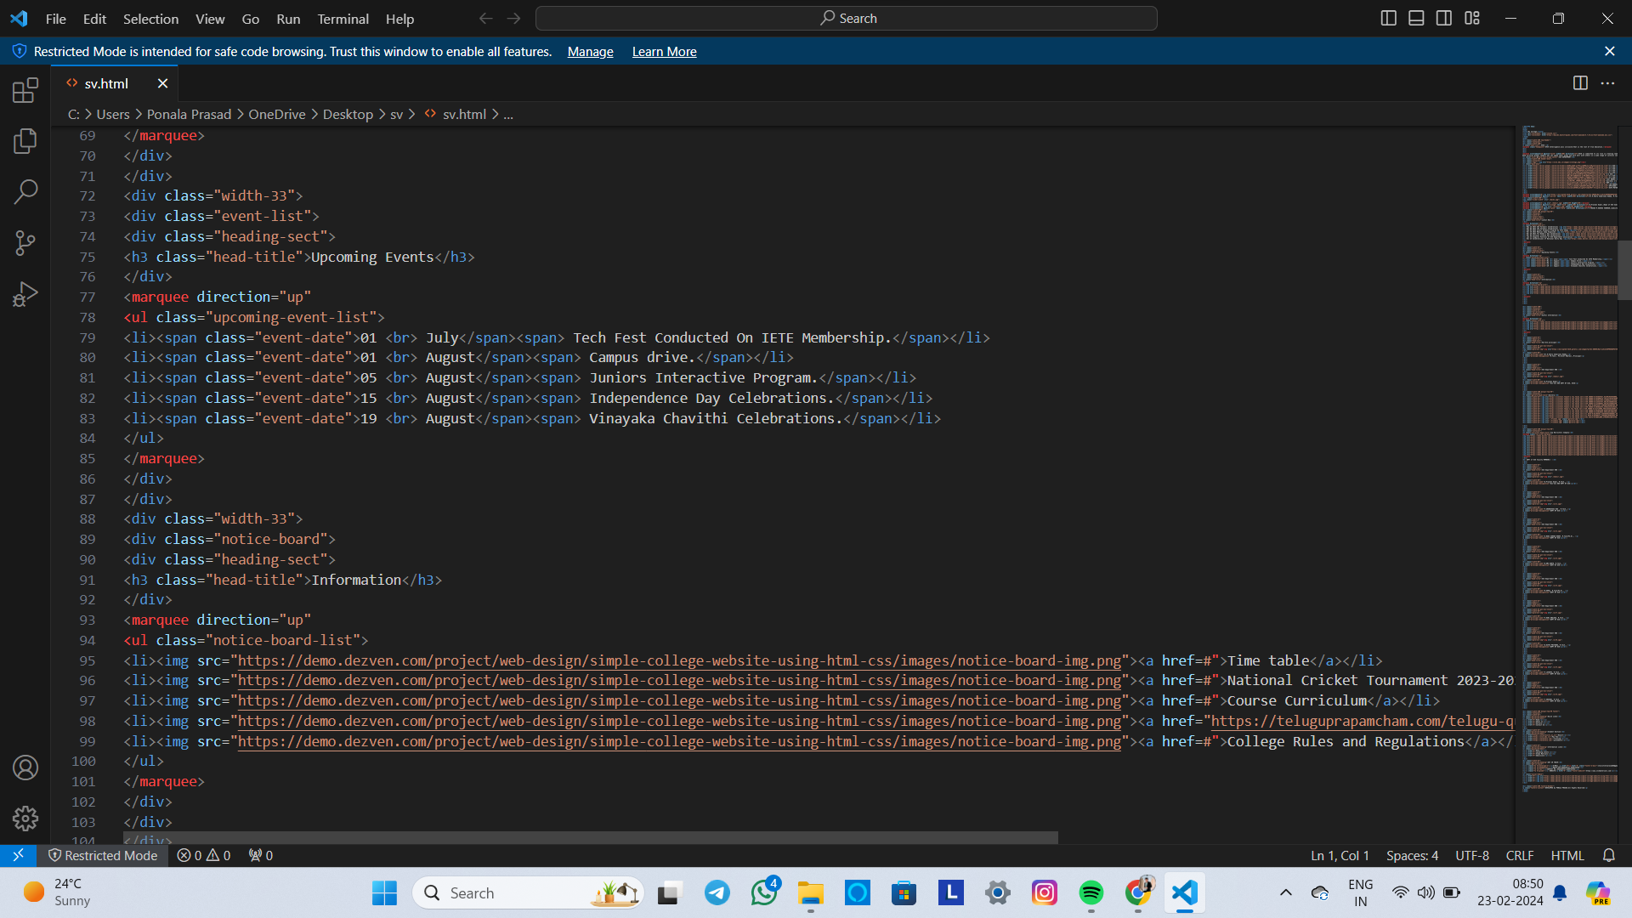lin

nav ul li

# 

**OUTPUT :-**

